**Be Yourself**

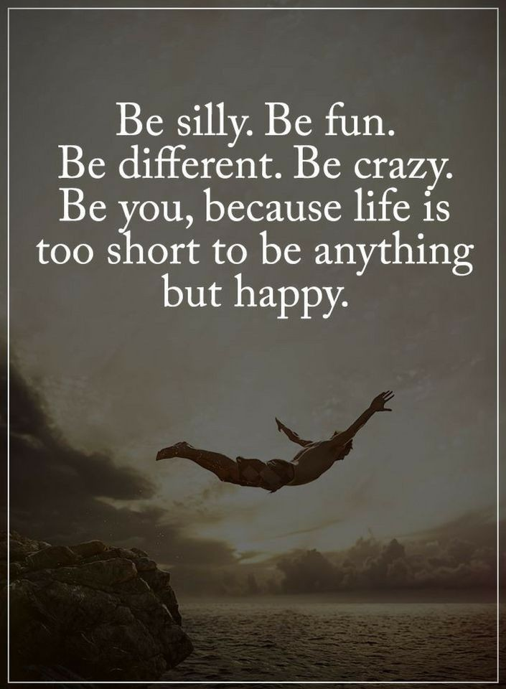

Who are you? It’s a very easy but a important question of everyone's life. We all are living with two personalities; first who wants to have a life that he dreams and second who is living the life on the rules of someone else. But are you really happy with your life? The answer is NO. You have only one life; so live it on your rules, on your conditions. Don’t try to change your for other.

**How to be yourself ?**

* **Respect of what you are**

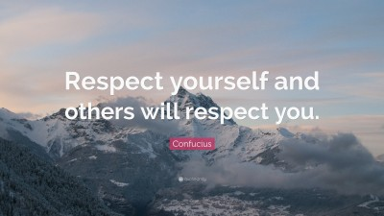

Until you don’t respect yourself, you can’t be happy in your life.

You think that you don’t get any fame ,value , respect if you can’t be what the society wants. But that’s not true. If you don’t give respect to yourself then how the other will give you respect?

If you are avoiding the actual you then you are wasting your life. It’s your life , you are free to live it as you want , take your own decisions , make your own choices . Live the way you want, say what you want and do what you want . Don’t care about what the people say ,what they think. Because you don’t have a choice either you lose your own personality and become a robot controlled by the society or be the person you want.

* **Don’t let your inner child die**

You see how the children play and enjoy freely, without any tension. They never care about what the other people are saying . They do whatever they want to do . You also need to do the same . You all have a small child inside your heart . You just need to find it .

You do so many things to be fit in the society but in this act you somewhere lose yourselves. If you are not worrying about being judged by the society, you can live in the better way.

So always keep in touch with your inner child ,it keeps remembering you to be yourself.

* **Aware of your thoughts**

Everyday so many thoughts are going on in your mind and most of them are negative. So just take five to ten minutes in every morning and sit quietly. Many thoughts will come and go in your mind, just let them doing this without getting attached to them. This will help you to know about the quality of your thoughts, moving ahead of old beliefs and be more present . All this can help to reveals your true personality.

* **Follow your intuitions**

This is one of the most important factor to be yourself. Follow your intuition. You ignore you intuitions because you are so obligated to others. Never ignore your intuitions for anyone , for anything. When you start following your wishes ,your urges that you have , you will get more happiness. It’s not bad to think about yourself, about your wishes . Never thought of that if you are fulfilling your dreams , you are selfish . You are not selfish , this shows how much you love yourself . And loving yourself is not a crime. Just follow your intuition and do whatever you want.

You got a life so don’t waste it in being the one who you are not. Just give respect to yourself . Be the person who you are , not the one that other wants . It’s your life live it on your terms . Don’t think what the society says , do what you really want to do . Because being yourself is the only to respect , happiness , and success. So  **‘different, be unique, be yourself'** .